Ukulele Songbook

Vol 4

1. Down To The River To Pray – Traditional

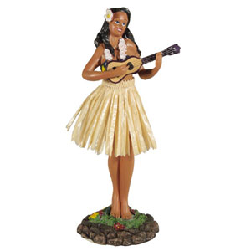3. Man Of Constant Sorrow – Soggy Bottom Boys

5. Running To Stand Still – U2

7. Basket Case – Green Day

8. Undone – Weezer

9. Sweet Dreams – Eurythmics

11. More Than A Feeling – Boston

13. White Rabbit – Jefferson Airplane

14. The Dragonborn Comes – Skyrim Theme

15. Ants Marching – Dave Matthews Band

17. A Long December – Counting Crows

19. Bring Me To Life – Evanescence

21. Behind Blue Eyes – The Who

23. Radioactive – Imagine Dragons

25. Boulevard of Broken Dreams – Green Day

27. In The Arms of the Angel – Sarah McLachland

29. The Hero of Canton – Joss Whedon/Firefly

31. Feliz Navidad – Traditional

33. The Unforgiven – Metallica

34. My Girl – The Temptations

35. Still Alive – Jonathan Coulton

v 1.1

**Down To The River To Pray – Traditional**

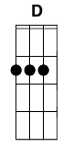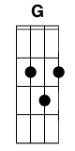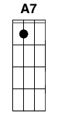

**D G D**

As I went in the river to pray

**A7 D G**

Studying about that good old way

**A7 D G**

And who shall wear, the starry crown

**A7 G D**

Good lord, show me the way

**A7 D G D**

O sisters let's go down

**G D**

Let's go down, come on down

**A7 D G D**

O sisters let's go down,

**G D**

Down in the river to pray

**D G D**

As I went in the river to pray

**A7 D G**

Studying about that good old way

**A7 D G**

And who shall wear, the starry crown

**A7 G D**

Good lord, show me the way

**A7 D G D**

O brothers let's go down,

**G D**

Let's go down, come on down

**A7 D G D**

Come on brothers let's go down

**G D**

Down in the river to pray

**D G D**

As I went in the river to pray

**A7 D G**

Studying about that good old way

**A7 D G**

And who shall wear, the starry crown

**A7 G D**

Good lord, show me the way

**A7 D G D**

O fathers let's go down,

**G D**

Let's go down, come on down

**A7 D G D**

O fathers let's go down

**G D**

Down in the river to pray

**D G D**

As I went in the river to pray

**A7 D G**

Studying about that good old way

**A7 D G**

And who shall wear, the starry crown

**A7 G D**

Good lord, show me the way

**A7 D G D**

O mothers let's go down,

**G D**

Let's go down, come on down

**A7 D G D**

Come on mothers let's go down

**G D**

Down in the river to pray

**D G D**

As I went in the river to pray

**A7 D G**

Studying about that good old way

**A7 D G**

And who shall wear, the starry crown

**A7 G D**

Good lord, show me the way

**A7 D G D**

O sinners let's go down,

**G D**

Let's go down, come on down

**A7 D G D**

O sinners let's go down

**G D**

Down in the river to pray

**D G D**

As I went in the river to pray

**A7 D G**

Studying about that good old wa

**A7 D G**

And who shall wear, the starry crown

**A7 G D**

Good lord, show me the way

**Man Of Constant Sorrow – Soggy Bottom Boys**

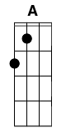

**D A D**

In constant sorrow all through his days

**D G**

I Am A Man Of Constant Sorrow

**A D**

I've seen trouble all my day.

**G**

I bid farewell to old Kentucky

**A D**

The place where I was born and raised.

**A D**

The place where he was born and raised

**D G**

For six long years I've been in trouble

**A D**

No pleasures here on earth I found

**G**

For in this world I'm bound to ramble

**A D**

I have no friends to help me now.

**A D**

He has no friends to help him now

**D G**

It's fare thee well my old lover

**A D**

I never expect to see you again

**G**

For I'm bound to ride that northern railroad

**A D**

Perhaps I'll die upon this train.

**A D**

Perhaps he'll die upon this train.

**D G**

You can bury me in some deep valley

**A D**

For many years where I may lay

**G**

Then you may learn to love another

**A D**

While I am sleeping in my grave.

**A D**

While he is sleeping in his grave.

**D G**

Maybe your friends think I'm just a stranger

**A D**

My face you'll never see no more.

**G**

But there is one promise that is given

**A D**

I'll meet you on God's golden shore.

**A D**

He'll meet you on God's golden shore.

**Running To Stand Still – U2**



**D G**

So she woke up, woke up from where she was, lyin' still

**D G**

Said "I, I gotta do somethin' about where we're goin'"

**D**

Stepped on steam train

**G**

Stepped out of the driving rain, maybe

**D G**

Run from the darkness, in the night.

**A**

Singing Ah,

**G**

Ah-la-la-la-de-day

**A C G**

Ah-la-la-la-de-day

**D G**

Ah-la-la-de-day

**D G**

Sweet the sin, bitter the taste in my mouth

**D G**

I see seven towers, but I only see one way out

**D**

You gotta cry without weeping, talk without speaking

**G**

scream without raising your voice

**D**

You know I took the poison

**G**

From the poison stream, then I floated, out of here

**A**

Singing Ah,

**C G**

Ah-la-la-la-de-day

**A C G**

Ah-la-la-la-de-day

**D**

Ah-la-la-de-day

**D G**

Oooooooooooo, Ooo Ooo Ooo Oooooo

**D G**

Oooooooooooo, Ooo Ooo Ooo Oooooo

**D**

She runs through the streets with eyes painted red

**G**

Under a black belly of clouds in the rain

**D**

in through a doorway, she brings me

**G**

white gold and pearls stolen from the sea

**D G**

she is raging she is raging and storm blows up in her eyes

She will,

**A C G A**

suffer the needle chill,

**C G D**

She's running to stand, still.

**Basket Case – Green Day**

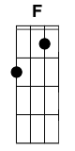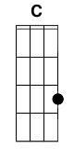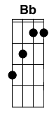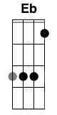

**F C**

Do you have the time

**Dm Am**

To listen to me whine

**Bb F C**

About nothing and everything all at once

**F C**

I am one of those

**Dm Am**

Melodramatic fools

**Bb F C**

Neurotic to the bone no doubt about it

**Bb C F**

Sometimes I give myself the creeps

**Bb C F**

Sometimes my mind plays tricks on me

**Bb C**

It all keeps adding up

**F Eb Dm** (drums come in)

I think I'm cracking up

**Bb C**

Am I just paranoid?

**F**

I'm just stoned

**F C Bb C** x2

I went to a shrink

To analyze my dreams

She says it's lack of sex that's bringing me down

I went to a whore

He said my life is a bore

And quit my whining 'cause it's bringing her down

~Chorus~

**F C Bb C** x4

**Bb C**

Grasping to control

**F C**

So you better hold on

**Dm Am A# F C F C Dm Am A# F C**

~Chorus~

**Am Bb Am Bb**

**Bb F C** (4x)

**Undone (The Sweater Song) – Weezer**



**G C D C**

I me, Me be, Goddamn, I am

**G C D C**

I can, Sing and, here me, Know me

**G C D C**

If you want to destroy my sweater

**G C D C**

Hold this thread as I walk away

**G C D C**

watch me unravel I'll soon be naked

**G C D C**

Lying on the floor, I've come undone

**G C D C**

Oh no, It go, It gone, Bye-bye (bye)

**G C D C**

Who I, I think, I sink, and I die!

**G C D C**

I don’t want to destroy your tank-top

**G C D C**

Let's be friends and just walk away

**G C D C**

Hate to see you lyin' there

**G C D C**

Lying on the floor, I've come undone

**Sweet Dreams – Eurythmics**

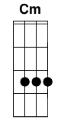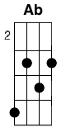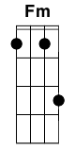

**Cm Ab G**

Sweet dreams are made of this

**Cm Ab G**

Who am I to disagree?

**Cm Ab G**

Travel the world and the seven seas

**Cm Ab G**

Everybody's looking for something

**Cm Ab G**

Some of them want to use you

**Cm Ab G**

Some of them want to get used by you

**Cm Ab G**

Some of them want to abuse you

**Cm Ab G**

Some of them want to be abused

Brigde: **Fm / Ab G / Cm / Ab / Fm / Ab G /**

*Repeat Verse 1*

*Repeat Brigde*

**Cm**

Hold your head up, movin' on

**F**

Keep your head up, movin' on

**Cm**

Hold your head up, movin' on

**F**

Keep your head up, movin' on

**Cm**

Hold your head up, movin' on

**F**

Keep your head up, movin' on

**Cm / Ab G /** x4

**Cm Ab G**

Some of them want to use you

**Cm Ab G**

Some of them want to get used by you

**Cm Ab G**

Some of them want to abuse you

**Cm Ab G**

Some of them want to be abused

Brigde: **Fm / Ab G / Cm / Ab / Fm / Ab G /**

**Cm Ab G**

Sweet dreams are made of this

**Cm Ab G**

Who am I to disagree?

**Cm Ab G**

Travel the world and the seven seas

**Cm Ab G**

Everybody's looking for something

N.C.

Sweet dreams are made of this

Who am I to disagree?

Travel the world and the seven seas

Everybody's looking for something

**Cm Ab G**

Sweet dreams are made of this

**Cm Ab G**

Who am I to disagree?

**Cm Ab G**

Travel the world and the seven seas

**Cm Ab G**

Everybody's looking for something

**More Than A Feeling – Boston**

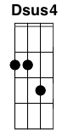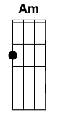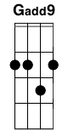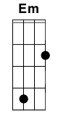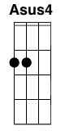

**D Dsus4 D C G** 4x

**D Dsus4 C G**

I looked out this morning and the sun was gone

**D Dsus4 C G**

Turned on some music to start my day

**D Dsus4 C G**

I lost myself in a familiar song

**D Dsus4 Am Dsus4 Gadd9**

I closed my eyes and I slipped away

**C Em D**

**G C Em D** 2x

**G C Em D**

It’s more than a feeling, more than a feeling

**G C Em D**

when I hear that old song, they used to play (more than a feeling)

**G C Em D**

I begin dreaming (more than a feeling)

**G C Eb**

till I see Marianne walk away

**Em A Asus4 D**

I see my Marianne walkin away

**D Dsus4 C G**

So many people have come and gone

**D Dsus4 C G**

Their faces fade as the years go by

**D Dsus4 C G**

Yet I still recall as I wander on

**D Dsus4 Am Dsus4 Gadd9**

As clear as the sun in the summer sky

**C Em D**

**G C Em D** 2x

**G C Em D**

It s more than a feeling, more than a feeling

**G C Em D**

when I hear that old song, they used to play (more than a feeling)

**G C Em D**

I begin dreaming (more than a feeling)

**G C Eb**

till I see Marianne walk away

**Em A Asus4 D**

I see my Marianne walkin away

solo

**D Dsus4 C G**

When I m tired and thinking cold

**D Dsus4 C G**

I hide in my music, forget the day

**D Dsus4 C G**

And dream of a girl, I used to know

**D Dsus4 Am D**

I closed my eyes and she slipped away

**Am Dsus4 D Gadd9**

she slipped away.

**C Em D**

**G C Em D** 2x

**G C Em D**

It’s more than a feeling, more than a feeling

**G C Em D**

when I hear that old song they used to play (more than a feeling)

**G C Em D**

I begin dreaming (more than a feeling)

**G C G**

till I see Marianne walk away

**G C Em D** 5x

**White Rabbit – Jefferson Airplane**

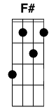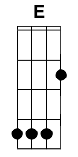

**F# G**

One pill makes you larger and one pill makes you small

**F# G**

and the ones that mother gives you don't do anything at all

**A C D A**

go ask Alice when she's ten feet tall

**F# G**

And if you go chasing rabbits and you know you're going to fall

**F# G**

Tell'em a hooka smoking caterpillar has given you the cord

**A C D A**

Call Alice when she was just small

**E A**

When men on the chessboard get up and tell you where to go

**E A**

and you just had some kind of mushroom and your mind is moving low

**F#**

go ask Alice, I think she'll know

**G**

When logic and proportion have fallen sloppy dead

**F#**

and the white knight is talking backwards

**G**

and the red queen's off with her head

**A C D A**

Remember what the Dormouse said

**E A E A**

Feed your head! Feed your head!

**E A**

Feed your head!

**The Dragonborn Comes – Skyrim Theme**

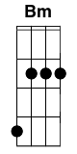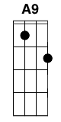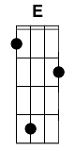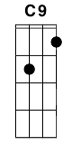

**BmDm AC BmDm**

Our Hero, our Hero claims a warrior's heart

**BmDm AC BmDm**

I tell you, I tell you the Dragonborn comes

**BmDm A9C9 BmDm**

With a voice wielding power of the ancient Nord Art

**BmDm A9C9 BmDm**

Believe, believe the Dragonborn comes

**BmDm A9C9 BmDm**

It's an end to the evil, of all Skyrim's foes

**BmDm A9C9 BmDm**

Beware, beware the Dragonborn comes

**BmDm A9C9 BmDm**

For the darkness has passed and the legend yet grows

**BmDm A9C9 BmDm**

You'll know, you'll know the Dragonborn's come.

(Morrowind)

**BmDm DF A9C9 EG**

**BmDm DF GBb EG**

**BmDm DF GBb A9C9**

(Sons of Skyrim)

**BmDm GBb**

Dovahkiin Dovahkiin

**AC EG**

Naal ok zin los vahriin

**GBb EG F#A BmDm**

wah dein vokul mahfaeraak ahst vaal

**BmDm GBb**

ahrk fin norok paal graan

**AC EG**

fod nust hon zindro zaan

**GBb EG F#A BmDm**

Dovahkiin fah hin kogaan mu draal

**Ants Marching – Dave Matthews Band**



Intro:

Phrase 1: | 1(3)+ + | 1(3)+ + | 1(3)+ + | 1(3)+ + |

| **D** | **Dsus4** | **D** | **Dsus4** |

A|-5---5-5-|-5---5-5-|-5---5-5-|-5---5-5-|

E|-2---2-2-|-3---3-3-|-2---2-2-|-3---3-3-|

C|-2---2-2-|-2---2-2-|-2---2-2-|-2---2-2-|

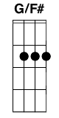 G|-2---2-2-|-2---2-2-|-2---2-2-|-2---2-2-|

Phrase 2 (also for verses, interlude, solo):

1 + a 2 + a 3 + a 4 + 1 + a 2 + a 3 + a 4 + |

| **D** | **G**

A|-5--X-X-X----------------|-2--X-X-X----------------|

E|-2--X-X-X------2-----2---|-3--X-X-X----------------|

C|-2--X-X-X--1-2---1-2---2-|-2--X-X-X--1-2---1-2---2-|

G|-2--X-X-X----------------|-0--X-X-X------0-----0---|

**Verse 1:**

**D** **G**

He wakes up in the morning

**D** **G**

Does his teeth, bite to eat and he's rolling.

**D** **G**

He never changes a thing

**D** **G**

The week ends, the week begins. She thinks,

**D** **G**

We look at each other

**D** **G**

Wondering what the other is thinking

**D** **G**

But we never say a thing

**D** **G**

And these crimes between us grow deeper.

(Phrase 2 above 2x)

**Chorus 1:**

**D** **G**

Take these chances

**D** **G**

Place them in me that sounds like a

**Bm** **D**

quieter time

**G** **Bm** **A**

Lights down you up and die

(Phrase 2 above 2x)

**Verse 2:**

**D** **G**

Goes to visit his mommy

**D** **G**

She feeds him well, has concerns he forgets them

**D** **G**

And remembers being small

**D** **G**

Playing under the table and dreaming

**Chorus:**

**Bm** **D** **G** **Bm** - **A**

Take these chan-ces

**Bm** **D** **G** **Bm** **A**

Place them in me that sounds like a

**Bm** **D**

quieter time

**G** **Bm** **A**

Lights down you up and die

Interlude/Solo (Verse Progression) X4

**Verse 3:**

**D** **G**

Driving in on this highway

**D** **G**

All these cars end up on the sidewalk

**D** (mute) **G**

People in every direc-tion

**D** (mute) **G** (mute)

No words exchanged, no time to exchange them

**Bridge:**

**G** **G/F#** **Em**

When all the little ants are marching

**G** **G/F#** **Em**

Red and black antennas waving

**G** **G/F#** **Em**

They all do it the same

**G** **G/F#** **Em**

They all do it the same way

Interlude: (Phrase 2 above)

**Verse 4:**

**D**

Candyman tempting the thoughts of a

**G**

Sweet tooth, torturing the weight loss

**D**

Program cutting the corners

**G**

of a loose end, loose end, cut cut

**D** **G**

On the fence, not to of-fend cut cut, cut cut

**Chorus:**

**Bm** **D** **G** **Bm** - **A**

Take these chan-ces

**Bm** **D** **G** **Bm** **A**

Place them in me that sounds like a

**Bm** **D**

quieter time

**G** **Bm** **A**

Lights down you up and die

Outro: **D** **G**

A|----------------------------------|----------------------------------|

E|-4--5--5--5--5-----5-----5-----5--|----------------------------------|

C|----------------------------------|----------------6-----6-----6-----|

G|----------------6-----6-----6-----|-6--7--7--7--7-----7-----7-----7--|

**G** **Bm** **A**

Lights down you up and die

**A Long December – Counting Crows**



intro: **G C Am C G C Am**

**C G D Am**

A long December and there's reason to believe

**C G C**

Maybe this year will be better than the last

**Am C G D**

I can't remember the last thing that you said

**Am**

as you were leavin'

**G C**

Now the days go by so fast

**G C Am C**

And it's one more day up in the canyons

**G C Am C**

And it's one more night in Hollywood

**G C Am** (mute) **G**

If you think that I could be forgiven...I wish you would

*Chorus:*

**G C**

Na na na na

**Am D**

Na na na na na na na na na

**G C Am**

Na na na na yeah

**C G D**

The smell of hospitals in winter

**Am C G C**

And the feeling that it's all a lot of oysters, but no pearls

**G D**

All at once you look across a crowded room

**C G C**

To see the way that light attaches to a girl

**G C Am C**

And it's one more day up in the canyons

**G C Am C**

And it's one more night in Hollywood

**G C Am**

If you think you might come to California...I think you should

*Chorus*

**C G D Am**

Drove up to the Hillside Manor sometime after two a.m.

**C G C**

And talked a little while about the year

**G D Am**

I guess the winter makes you laugh a little slower

**C G**

Makes you talk a little lower about

**C**

the things you could not show her

**G D Am**

And it's been a long December and there's reason to believe

**C G C**

Maybe this year will be better than the last

**G D Am**

I can't remember all the times I tried to tell myself

**C G C**

To hold on to these moments as they pass

**G C Am**

And it's been one more day up in the canyons

**G C Am**

And it's one more night in Hollywood

**G C Am**

It's been so long since I've seen the ocean...I guess I should

*Chorus*

**Bring Me To Life – Evanescence**

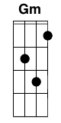

**Em C Am**

How can you see into my eyes

**D**

like open doors

**Em C Am**

Leading you down into my core

**D**

where I've become so numb

**Em C Am**

Without a soul

**D Em**

my spirit's sleeping somewhere cold

**C Am**

until you find it there and lead

**D**

it back home

Chorus:

**Em**

Wake me up inside

**Gm D**

Wake me up inside

**Em C Am**

Call my name and save me from the dark

**Em**

Bid my blood to run

**Gm D**

before I come undone

**Em C Am**

Save me from the nothing I've become

**Em C Am**

Now that I know what I'm without

**D**

you can't just leave me

**Em C**

Breathe into me

**Am**

and make me real

**D**

Bring me to life

*Chorus*

*Bridge:*

**Am Gm C**

Frozen inside without your touch

**Gm**

without your love darling

**Am Gm C Am**

only you are the life among the dead

*Chorus*

**C D Em**

Bring me to life

**C D Em**

Bring me to life

**Behind Blue Eyes – The Who**

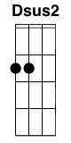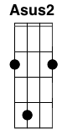

Intro: **Em G D Dsus2 C A(sus2)**

**Em G**

No one knows what it's like

**D Dsus2**

to be the bad man

**C**

to be the sad man

**A(sus2)**

behind blue eyes

**Em G**

No one knows what it's like

**D Dsus2**

to be hated

**C**

to be fated

**A(sus2)**

to telling only lies

*Chorus:*

**C D**

But my dreams

**G**

they aren't as empty

**C D E**

as my conscience seems to be

**Bm C**

I have hours, only lonely

**D**

my love is vengeance

**A(sus2)**

thats never free

**Em G**

No one knows what it's like

**D Dsus2**

to feel these feelings

**C**

like I do

**A(sus2)**

and I blame you

**Em G**

No one bites back as hard

**D Dsus2**

on their anger

**C**

none of my pain and woe

**A(sus2)**

can show through

~chorus~

Bridge: **E Bm A**

**E Bm A**

When my fist clenches, crack it open

**E Bm G D**

Before I use it and lose my cool

**Bm A D**

When I smile, tell me some bad news

**Bm A E Bm A**

Before I laugh and act like a fool

**E Bm A E**

And if I swallow anything evil

**Bm G D**

Put your finger down my throat

**Bm A D**

And if I shiver, please give me a blanket [Bsus2] [A] [D]

**Bm A E**

Keep me warm, let me wear your coat

**Bm Bm A D** (x3)

**Bm** (hold)

**Em G**

No one knows what it's like

**D Dsus2**

to be the bad man

**C**

to be the sad man

**A(sus2)**

behind blue eyes

**Radioactive – Imagine Dragons**



**Am C G**

I'm waking up to ash and dust

**D Am**

I wipe my brow and I sweat my rust

**C G D**

I'm breathing in the chemicals

**Am C G D**

I'm breaking in, shaping up, then checking out on the prison bus

**Am C G**

This is it, the apocalypse

**G**

Whoa

**D Am C**

I'm waking up, I feel it in my bones

**G D**

Enough to make my systems grow

**Am C**

Welcome to the new age, to the new age

**G D**

Welcome to the new age, to the new age

**Am C G D**

Whoa, whoa, I'm radioactive, radioactive

**Am C G D**

Whoa, whoa, I'm radioactive, radioactive

**Am C G**

I raise my flags, don my clothes

**D Am**

It's a revolution, I suppose

**C G**

We're painted red to fit right in

**G**

Whoa

**Am C G D**

I'm breaking in, shaping up, then checking out on the prison bus

**Am C G**

This is it, the apocalypse

**G**

Whoa

**D Am C**

I'm waking up, I feel it in my bones

**G D**

Enough to make my systems grow

**Am C**

Welcome to the new age, to the new age

**G D**

Welcome to the new age, to the new age

**Am C G D**

Whoa, whoa, I'm radioactive, radioactive

**Am C G D**

Whoa, whoa, I'm radioactive, radioactive

*Single Strum*

**Am* C* G* D\***

All systems go, sun hasn't died

**Am* C* G* D\***

Deep in my bones, straight from inside

**D Am C**

I'm waking up, I feel it in my bones

**G D**

Enough to make my systems grow

**Am C**

Welcome to the new age, to the new age

**G D**

Welcome to the new age, to the new age

**Am C G D**

Whoa, whoa, I'm radioactive, radioactive

**Am C G D**

Whoa, whoa, I'm radioactive, radioactive

**Boulevard of Broken Dreams – Green Day**

Capo 1

Intro: **Em G D A** 2x

**Em G**

I walk a lonely road

**D A Em**

The only one that I have ever known

**G**

Don't know where it goes

**D A Em**

But it's home to me and I walk alone

**Em G D A**

**Em G**

I walk this empty street

**D A Em**

On the Boulevard of Broken Dreams

**G**

Where the city sleeps

**D A Em**

and I'm the only one and I walk alone

**G D A**

I walk alone

**Em**

I walk alone

**G D A**

I walk alone

I walk a...

*Chorus:*

**C G D Em**

My shadow's the only one that walks beside me

**C G D Em**

My shallow heart's the only thing that's beating

**C G D Em**

Sometimes I wish someone out there will find me

**C G B**

'Til then I walk alone

**Em G D A Em**

Ah-ah, Ah-ah, Ah-ah, Aaah-ah,

**G D A**

Ah-ah, Ah-ah, Ah-ah

**Em G**

I'm walking down the line

**D A Em**

That divides me somewhere in my mind

**G**

On the border line

**D A Em**

Of the edge and where I walk alone

**Em G D A**

**Em G**

Read between the lines

**D A Em**

What's fucked up and everything's alright

**G**

Check my vital signs

**D A Em**

To know I'm still alive and I walk alone

**G D A**

I walk alone

**Em**

I walk alone

**G D A**

I walk alone

I walk a...

*Chorus:*

**C G D Em**

My shadow's the only one that walks beside me

**C G D Em**

My shallow heart's the only thing that's beating

**C G D Em**

Sometimes I wish someone out there will find me

**C G B**

'Til then I walk alone

**Em G D A Em**

Ah-ah, Ah-ah, Ah-ah, Aaah-ah

**G D**

Ah-ah, Ah-ah

**A**

I walk alone

I walk a...

Solo: **C G D Em** 3x **C G B**

**Em G**

I walk this empty street

**D A Em**

On the Boulevard of Broken Dreams

**G**

Where the city sleeps

**D A**

And I'm the only one and I walk a...

*Chorus:*

**C G D Em**

My shadow's the only one that walks beside me

**C G D Em**

My shallow heart's the only thing that's beating

**C G D Em**

Sometimes I wish someone out there will find me

**C G B**

'Til then I walk alone

**In The Arms Of The Angel – Sarah McLachland**

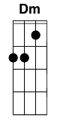

Capo 1

**Dm Am**

Spend all your time waiting for that second chance

**C F G**

for a break that would make it ok

**Dm Am**

There's always some reason to feel not good enough

**C F G**

and it's hard at the end of the day

**Dm F**

I need some distraction, oh beautiful relief

**C G**

Memories seep through my veins

**Dm F**

that may be empty, oh weightless and maybe

**C Dm G**

I'll find some peace tonight

Chorus:

**C**

In the arms of the angel

**Em**

fly away from here

**F**

from this dark cold hotel room

**C G**

and the endlessness that you feel

**C**

you are pulled from the wreckage

**Em**

of your silent reverie

**Dm Bb F**

you're in the arms of the angel

**C G C**

may you fi-ind some comfort here

**Dm Am**

so tired of the straight lines, everywhere you turn

**C F G**

there' vultures and thieves at your back

**Dm Am**

the storm keeps on twisting, keep on building the lies

**C F G**

that you make up for all that you lack

**Dm F**

it don't make no difference, escape one last time

**C G**

it's easier to believe

**Dm F**

in this sweet madness, oh this glorious sadness

**C Dm G**

brings me to my knees

Chorus:

**C**

in the arms of the angel

**Em**

fly away from here

**F**

from this dark cold hotel room

**C G**

and the endlessness that you feel

**C**

you are pulled from the wreckage

**Em**

of your silent reverie

**Dm Bb F**

you're in the arms of the angel

**C G C Em**

may you fi-ind some comfort here

**Dm Bb F**

you're in the arms of the angel

**C G C**

may you fi-ind some comfort here

**The Hero of Canton – Joss Whedon/Firefly**

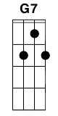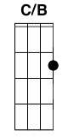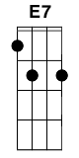

Capo 2

*Intro:* (only hit it once)

**C C**

Jayne The man they call Jayne

*Chorus:*

**C**

He robbed from the rich

**Am**

and he gave to the poor

**C**

Stood up to the man

**Am**

and he gave him what for

**F**

Our love for him now

**G7**

ain't hard to explain

**C**

The hero of Canton

**G7 C C/B...Am**

the man they call Jayne

*Verse 1:*

**Am E7 Am**

Now Jayne saw the mudders' backs breakin'

**Dm E7 Am**

He saw the mudders' lament

**Am E7 Am**

And he saw the Magistrate takin'

**Dm E7 Am**

every dollar and leavin' five cents

**Dm Am**

so he said "You can't do that to my people"

**Dm E7**

he said "can't crush them under your heel"

**Am E7**

Jayne strapped on his hat

**Am Dm**

and in 5 seconds flat

**Dsus2 E7 Am**

stole everything Boss Higgins had to steal

***~Chorus~***

*Verse 2:*

**Am E7 Am**

Now here is what separates heroes

**Dm E7 Am**

From common folk like you and I

**Am E7**

The man they call Jayne

**Am Dm**

He turned 'round his plane

**E7 Am**

And let that money hit sky

**Dm Am**

He dropped it onto our houses

**Dm E7**

He dropped it into our yards

**Am E7**

The man they call Jayne

**Am Dm**

He stole away our pain

**Dsus2 E7 Am**

And headed out for the stars

***~Chorus~***

**Feliz Navidad – Traditional**

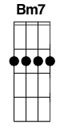

**G A7**

Feliz Navidad,

**D Bm7**

Feliz Navidad,

**Em A7 D**

Feliz Navidad, próspero ano y felicidad.

**G A7**

Feliz Navidad,

**D Bm7**

Feliz Navidad,

**Em A7 D**

Feliz Navidad, próspero ano y felicidad.

**G**

I wanna wish you a Merry Christmas,

**A7 D**

I wanna wish you a Merry Christmas,

**Bm7 Em**

I wanna wish you a Merry Christmas,

**A7 D**

from the bottom of my heart.

**G A7**

Feliz Navidad,

**D Bm7**

Feliz Navidad,

**Em A7 D**

Feliz Navidad, próspero ano y felicidad**.**

**G A7**

Feliz Navidad,

**D Bm7**

Feliz Navidad,

**Em A7 D**

Feliz Navidad, próspero ano y felicidad.

**G**

I wanna wish you a Merry Christmas,

**A7 D**

I wanna wish you a Merry Christmas, X2

**Bm7 Em**

I wanna wish you a Merry Christmas,

**A7 D**

from the bottom of my heart.

**G A7**

Feliz Navidad,

**D Bm7**

Feliz Navidad,

**Em A7 D**

Feliz Navidad, próspero ano y felicidad.

**G A7**

Feliz Navidad,

**D Bm7**

Feliz Navidad,

**Em A7 D**

Feliz Navidad, próspero ano y felicidad.

**G**

I wanna wish you a Merry Christmas,

**A7 D**

I wanna wish you a Merry Christmas,

**Bm7 Em**

I wanna wish you a Merry Christmas,

**A7 D**

from the bottom of my heart.

**G A7**

Feliz Navidad,

**D Bm7**

Feliz Navidad,

**Em A7 D**

Feliz Navidad, próspero ano y felicidad.

**The Unforgiven - Metallica**



**Am Em D Am**

New blood joins this earth and quickly he's sub-dued.

**Em D Am**

Through constant pain disgrace, the young boy learns their rules.

**Em D Am**

With time the child draws in this whipping boy done wrong.

**Em D Am**

Deprived of all his thoughts, the young man struggles on and on.

**C G C G**

He knows, ooh, a vow unto his own that never from this day

**C G E**

his will they'll take away.

*CHORUS:*

**Am C G Em Am**

What I've felt, what I've known never shined through in what I've shown.

**Am C G E Am**

Never be. Never see. Won't see what might have been.

**Am C G Em Am**

What I've felt, what I've known, never shined through in what I've shown.

**Am C G E Am**

Never free. Never me. So I dub the unforgiven.

**Am Em D Am**

They dedicate their lives to running all of his

**Em D Am**

He tries to please them all, this bitter man he is

**Em D Am**

Throughout the life the same, he's battled constantly

**Em D Am**

This fight he cannot win. A tired man they see no longer cares.

**C G C G**

The old man then prepares to die regretfully

**C G E**

That old man here is me.

**~Chorus~**

**My Girl – The Temptations**



A|-----------3-|-----------3-|-------3-5---|-------3-5---|

E|-----0-------|-----0-------|-1---------1-|-1---------1-|

C|-0-2---------|-0-2---------|-------------|-------------|

G|-------0-2---|-------0-2---|---0-2-------|---0-2-------|

**C F C**

I've got sunshine on a cloudy day

**C F C**

And when it's cold outside, I've got the month of May

CHORUS:

**C Dm F G**

Well, I guess you’d say,

**C Dm F G**

What can make me feel this way?

**C**

My girl...

**F G7**

Talkin' 'bout my girl

**C F C**

I've got so much honey the bees envy me

**C F C**

I've got a sweeter song, than the birds in the trees

*(Chorus)*

**C F C**

I don't need no money, fortune or fame

**C F C**

I've got all the riches, baby, one man can claim

*(Chorus)*

**Still Alive – Jonathan Coulton**



**D Bm**

This was a tri-umph

**D Bm D Bm D Bm**

I'm making a note here: huge suc-cess

**Em A D Bm D**

It's hard to over-state my satis-faction

**Bm D Bm**

Aperture Sci-ence

**D Bm D Bm D Bm**

We do what we must be-cause we can

**Em A Bb**

For the good of all of us, ex-cept the ones who are dead

**F C Bb F**

But there's no sense crying over every mis-take

**F C Bb F**

You just keep on trying till you run out of cake

**Gm C F Dm**

And the science gets done and you make a neat gun

**Bb A D Bm**

For the people who are still alive

**D Bm D Bm**

**D Bm D Bm**

I'm not even angry

**D Bm D Bm D Bm**

I'm being so sin-cere right now

**Em A D Bm D**

Even though you broke my heart and killed me

**Bm D Bm**

And tore me to pie-ces

**D Bm D Bm D Bm**

And threw every piece in-to a fire

**Em A Bb**

As they burned it hurt because I was so happy for you

**F C Bb F**

Now these points of data make a beautiful line

**F C Bb F**

And we're out of beta, we're re-leasing on time

**Gm C F Dm**

So I'm glad I got burned, think of all the things we learned

**Bb A D Bm**

For the people who are still a-live

**D Bm D Bm**

**D Bm D Bm**

Go ahead and leave me

**D Bm D Bm D Bm**

I think I'd pre-fer to stay in-side

**Em A D Bm D**

Maybe you'll find someone else to help you

**Bm D Bm**

Maybe Black Me-sa

**D Bm D Bm D Bm**

That was a joke, ha ha, fat chance

**Em A Bb**

Anyway this cake is great, It's so del-icious and moist

**F C Bb F**

Look at me still talking when there's science to do

**F C Bb F**

When I look out there it makes me glad I'm not you

**Gm C F Dm**

I've ex-periments to run, there is research to be done

**Bb A D Bm**

On the people who are still a-live

**D Bm D Bm**

And be-lieve me I am still a-live

**D Bm D Bm**

I'm doing science and I'm still a-live

**D Bm D Bm**

I feel fan-tastic and I'm still a-live

**D Bm D Bm**

While you're dying I'll be still a-live

**D Bm D Bm**

And when you're dead I will be still a-live

**D Bm**

Still A-live

Still A-live

Chords – GCEA (Standard) Tuning

Maj/Minor

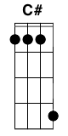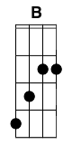

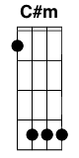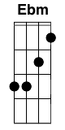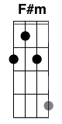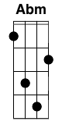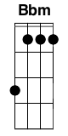

7

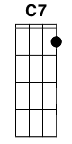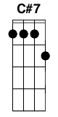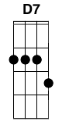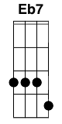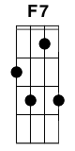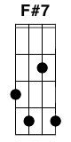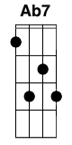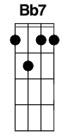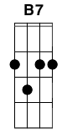

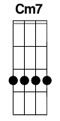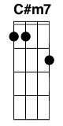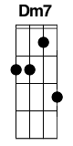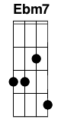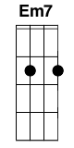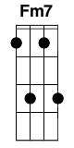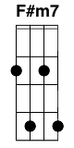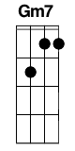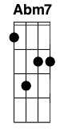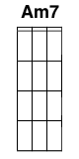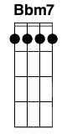

Maj

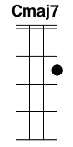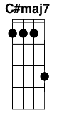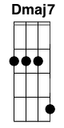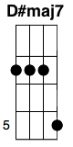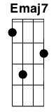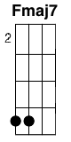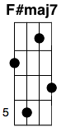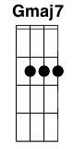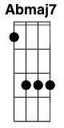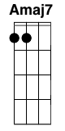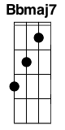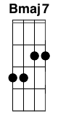

Sus

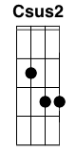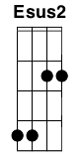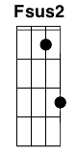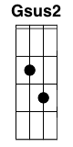

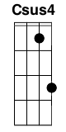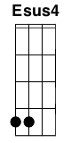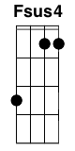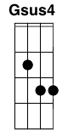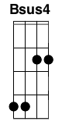

9

 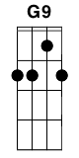 

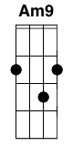

5

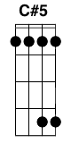 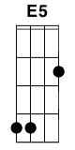 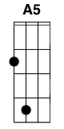 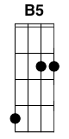

6

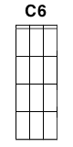 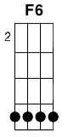 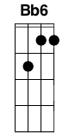

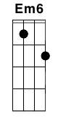 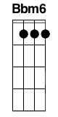

Misc

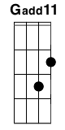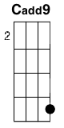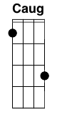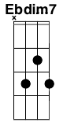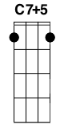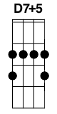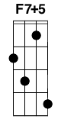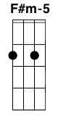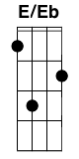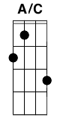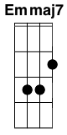

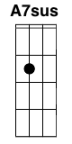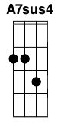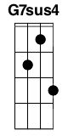

Variations

